Exercise No : 3

Date : 12/10/2020

**AIM :**

ToWrite a Python program to remove and print every second number from a list of numbers until the list becomes empty.

**PROGRAM:**

def every2number(list):

temp = []

p = 1

s = 0

for i in range(0,len(list)):

s = (p+s) % len(list)

el = list.pop(s)

temp.append(el)

return temp

n = int(input("enter the array size: "))

list = []

for i in range (0,n):

list.append(int(input("enter the values: ")))

p = every2number(list)

print(p)

**LINK:**

[**http://103.53.53.18/mod/vpl/forms/edit.php?id=231&userid=1783**](http://103.53.53.18/mod/vpl/forms/edit.php?id=231&userid=1783)

**OUTPUT:**

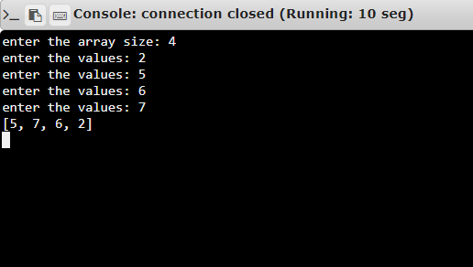

**RESULT:**

The output has been successfully executed and verified.